**Led blink 1s delay switch**  
  
int led =7;

int s=6;

int state;

void setup() {

  // put your setup code here, to run once:

pinMode(led,OUTPUT);

pinMode(s,INPUT);

}

void loop() {

  // put your main code here, to run repeatedly:

digitalWrite(led, HIGH);

state= digitalRead(s);

if(state==HIGH)

{

  digitalWrite(led, HIGH);

}

else{

  digitalWrite(led, LOW);

  delay(1000);

}

}

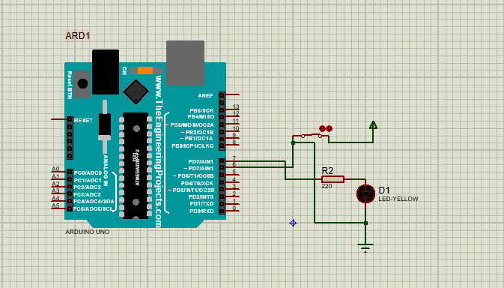

Ir sensor

int irpin =7;

int irvalue;

void setup() {

pinMode(irpin, INPUT);

}

void loop() {

  // put your main code here, to run repeatedly:

irvalue = digitalRead(irpin);

Serial.print("Show irvalue =");

Serial.print(irvalue);

Serial.begin(9600);

}

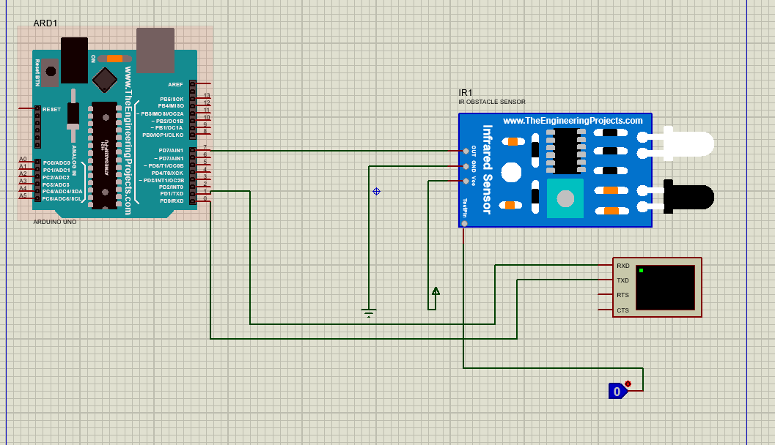

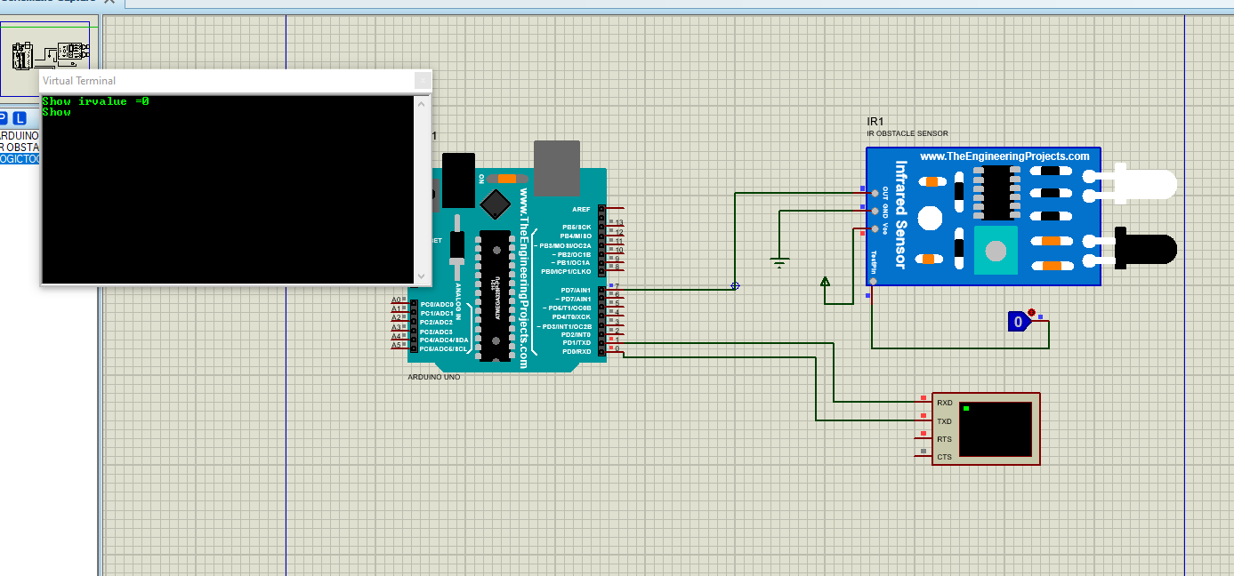

int irpin =7;

int irvalue;

void setup() {

pinMode(irpin, INPUT);

}

void loop() {

  // put your main code here, to run repeatedly:

irvalue = digitalRead(irpin);

Serial.print("Show irvalue =");

Serial.println(irvalue);

Serial.begin(9600);

delay(500);

}